Sensor Test Results

Zheng Lu, 10/25/2013

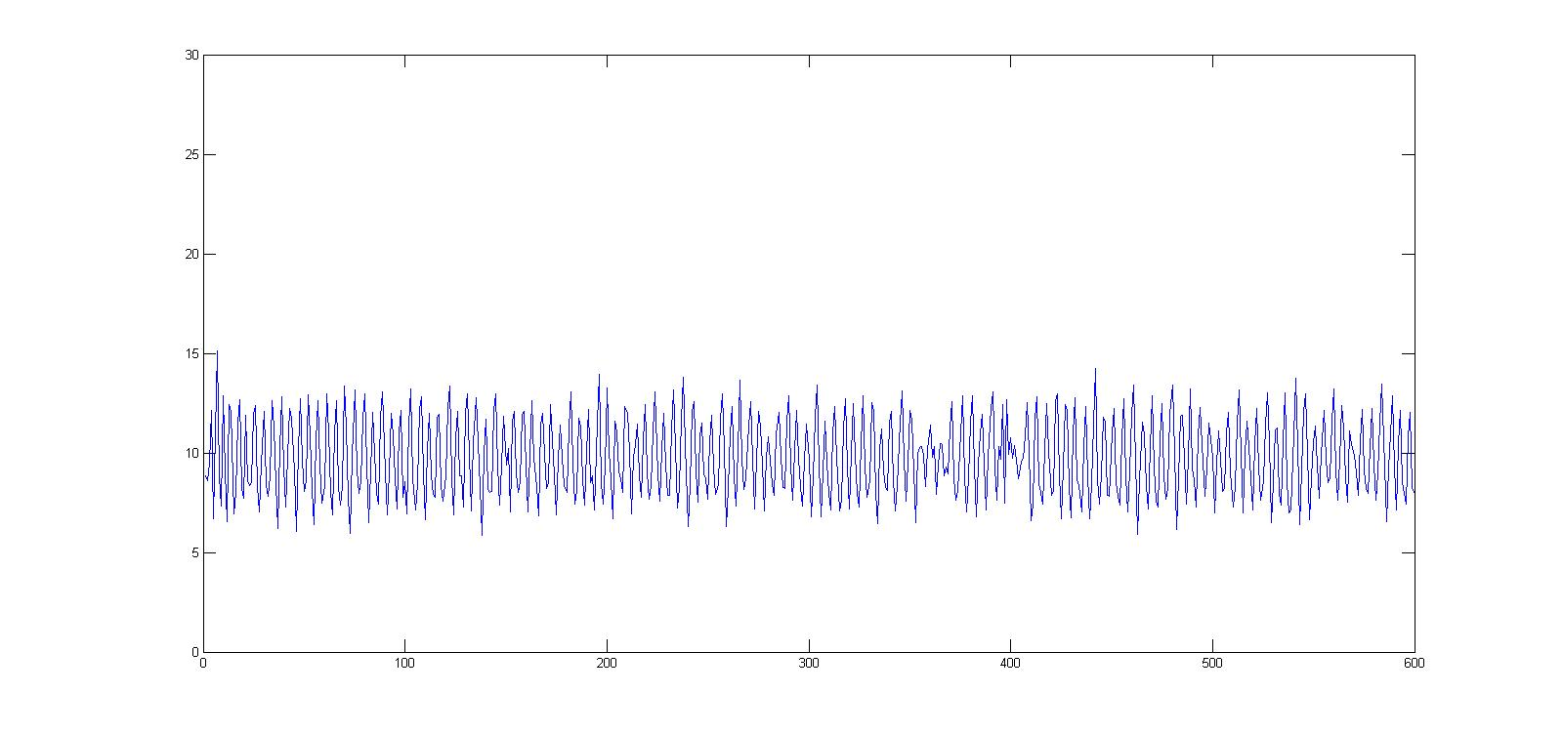

Figure phone flat Accelerometer L2 norm

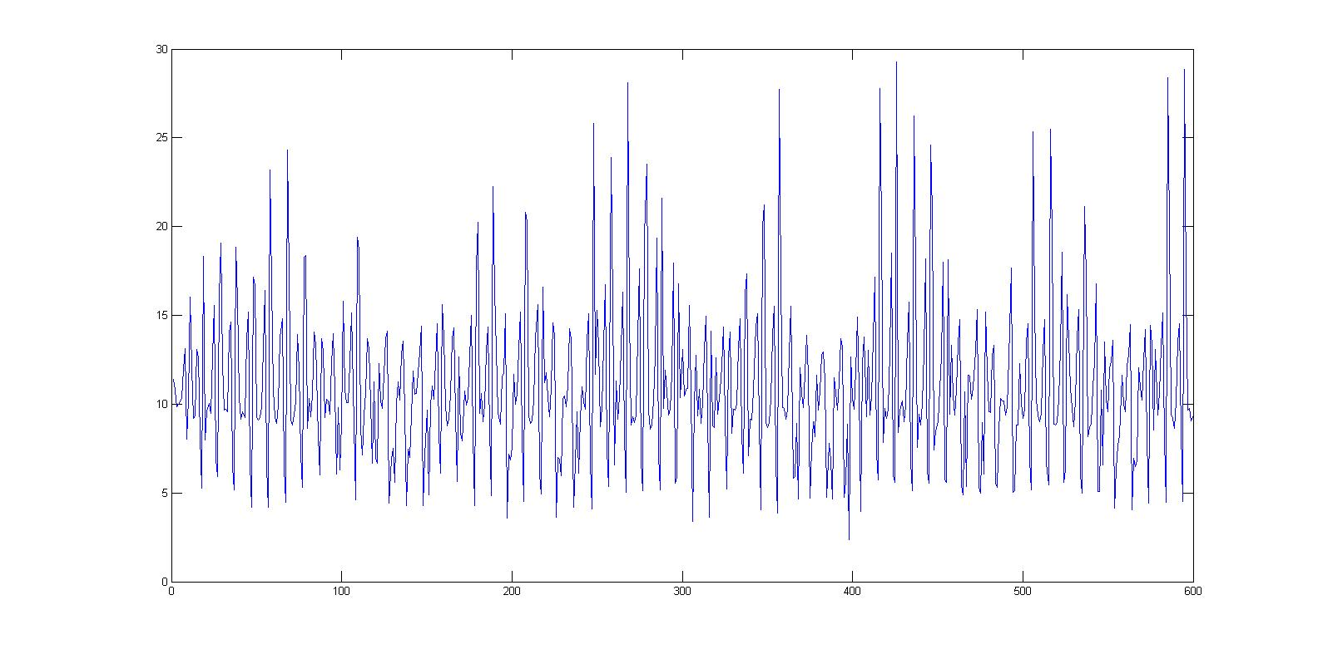

Figure phone in left pocket Accelerometer L2 norm

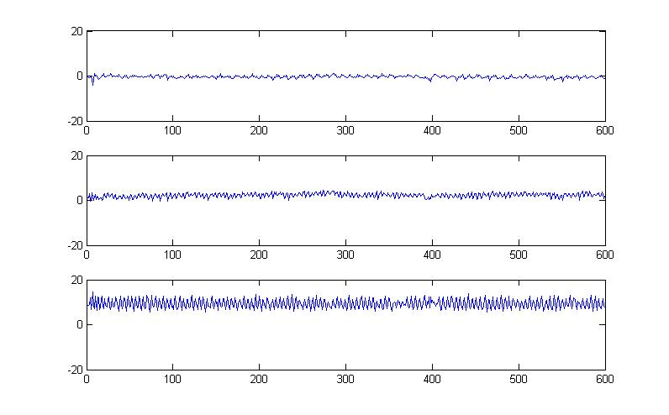

Figure phone flat Accelerometer xyz coordination

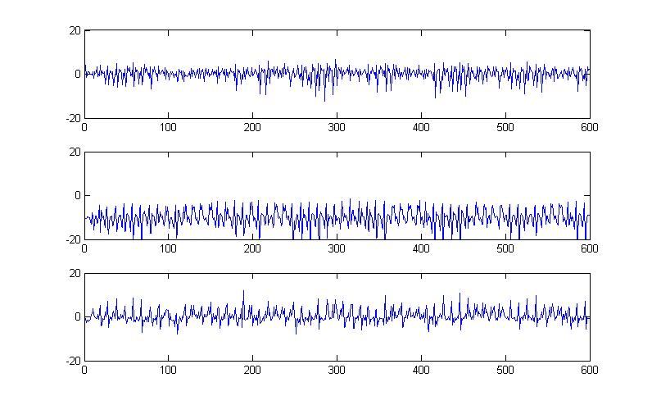

Figure phone in left pocket Accelerometer xyz coordination

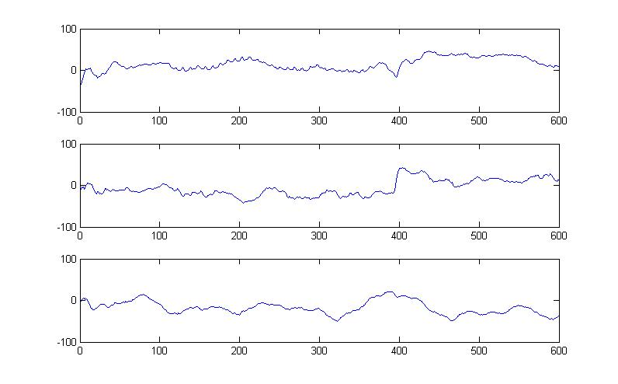

Figure phone flat Magnetometer xyz coordination

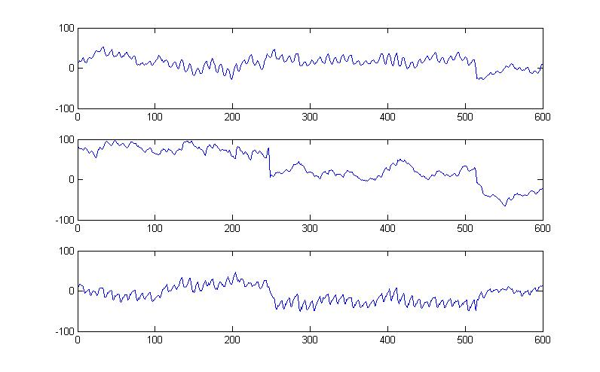

Figure phone in pocket Magnetometer xyz coordination

Some Conclusion:

1. Accelerometer readings are good to tell whether you are going forward or backward in 2D scenario, i.e. along a street.
2. Magnetometer can provide real-time information about when are we turning.